|  |
| --- |
|  |
| Undergraduate Final Year Project |
| Mobile Load-shedding Notifier for Electricity Supply Cooperation of Malawi |
| **Literature and Technology Review** |
| **jonathan mbendera** |
| **BSC (Honors) Business Information Technology** |

**Supervisor: Mrs. Funsani**

|  |
| --- |
|  |

Table of Contents

Introduction 4

Background 5

Technology review 6

Programming languages 6

HTML5 (Hypertext Markup Language) 6

Bootstrap CSS Framework 6

JavaScript (JS) 6

PHP (hypertext preprocessor) cake framework 6

My SQL (Structured Query Language) 6

Apache Cordova 6

Software tools 7

Visual studio code 7

WampServer 7

Microsoft Visio 7

Review of other systems 8

Magetsi Me 8

Advantages 8

Disadvantages 8

Myeskom customer app 9

Advantages 9

Disadvantages 9

Nepal load-shedding android app 10

Advantages 10

Disadvantages 10

Key issues to take to design and implementation stage of the project 12

Conclusion 13

References 14

# Introduction

The aim of this report is to review the technologies that are to be used to solve the problem which the consumers of Electricity Supply Cooperation of Malawi (ESCOM) are facing in knowing load-shedding schedules affecting their areas. ESCOM introduced a load-shedding program in order to ease the burden on supply and demand, customers find it difficult to keep track of the load-shedding programs, so with the introduction of the mobile app people will find it easier to kip track and plan according to the schedules.

# Background

Malawi’s electricity is generated from hydro with Shire River as the main source of the hydro-electricity. Shire River’s main source is lake Malawi. Electricity generation has been reduced by up to 40% due to dwindling water levels. Therefore, instead of generating a maximum capacity of 351 Mega Watts (MW) ESCOM is generating an average of 200MW, leaving a capacity shortfall of 150MW. This has resulted in increased load shedding periods. In view of the prevailing power crisis, a number of interventions, short, medium to long term have been put in place like load shifting for customers.

Load-shedding is a measure which is taken as a last resort when electricity supply doesn’t meet the actual demand, however sometimes power is interrupted due to maintenances or some other safety reasons, so due to these power outages customers need to be notified so that they can keep track of the power shifting affecting their areas, this helps in planning accordingly so to avoid being caught by surprise.

Load-shedding has both negative and positive impact on consumers and particularly manufacturers and industries as they all rely on electricity, below are the advantages and disadvantages of load-shedding.

Advantages

* Prevents system collapse and instability of generation of electricity and overall system distribution
* ensures even distribution of the available capacity that each consumer gets power
* Prevents total blackout

Disadvantages

* Loss of production since nowadays people rely on electricity

ESCOM came up with the electricity management system which was intended to notify or keep its customers aware of load-shedding schedules affecting their areas/locations, however the current system has flows which makes it not effective and it doesn’t serve the intended purpose.

Nowadays people rely on their mobile devices for just about any activity imaginable and any company that is not a part of this global trend seems to be out of reach.

# Technology review

This section will center on the software tools that have been used to develop this project, the reasons, advantages as well as the disadvantages.

## Programming languages

## HTML5 (Hypertext Markup Language)

Used for structuring and presenting content on a web, it is also well optimized for mobile devices. It offers good graphic handling and offers offline support, which will help users to use the system even offline. It also adds elements like form controls, multimedia components and other APIs that support geo location services. HTML5 is supported by almost all browsers, making it easy to implement and fit across different platforms and devices

## Bootstrap CSS Framework

It is a framework for developing responsive software applications like mobile apps, it is used for front-end development. It will help in the customization of the interface for the mobile app. For the app to be responsive to fit in all screen sizes or different resolutions be it on mobile phone or tablet pc’s, bootstrap will do the work with ease.

## JavaScript (JS)

A script used to create and control content on the website and also enhances HTML pages. It also supports most mobile browsers for user friendly experience.

## PHP (hypertext preprocessor) cake framework

According to the official Cake-PHP website defines Cake-PHP as a rapid development framework for PHP that provides an extensible architecture for developing, maintaining, and deploying applications. The framework follows the model view controller pattern which makes it easy for code structuring. This framework will be used to build the administrator’s panel, cake was chosen because of its robustness and security features.

## My SQL (Structured Query Language)

MySQL is an open source DBMS (Database Management System) that is very popular with web applications because of its speed, efficiency and ease of use. It works in the same way as most DBMS’s, the only difference being that it is specially made for the web and that it is better.

## Apache Cordova

it is an open source mobile development framework and it also offers a good platform for hybrid mobile applications like the one to be built. It is flexible in a sense of a way that it allows the use of HTML, CSS, JavaScript for cross-platform development.

## Software tools

Bellow are the software tools to be used in the development of the system.

### Visual studio code

It is a code editor to be used for code writing, it supports debugging, and also embedded with Git (version control system).

### WampServer

It is a windows web development environment, that allows the creation of web application.

### Microsoft Visio

Application for diagramming and vector graphics, to be used in the production of wire frames

(Anon., 2014-2019)

# Review of other systems

## Magetsi Me

It is an independent, community driven project from Malawi and it is not in any way affiliated with ESCOM. It is a web-based application which aims at providing a convenient way of getting insight on load-shedding schedules. It obtains its information through users and various media platforms used by ESCOM like Facebook, radio stations, news papers and websites. Below are the advantages and disadvantages of this system.

### Advantages

* Provides users with access to load-shedding schedules
* Provides a platform whereby users can report faults
* Gives immediate feedback
* The site is responsive that it can fit on any resolution
* The site has a search engine for users to search load-schedules for their areas

## Disadvantages

* The information may not be accurate since it doesn’t obtain its info directly to ESCOM
* Since it’s a web-based system it doesn’t offer offline support
* Doesn’t offer much information like current power status and causes of the outages in particular
* It requires internet connection all the time which may be expensive to the users
* It requires users to have an account to access some features
* It has some restriction depending on hardware used

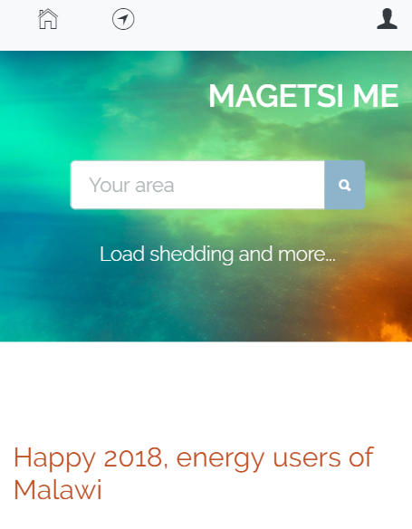fig 1 showing magetsi me home page

## Myeskom customer app

It is an application/mobile app owned by South African electricity public utility (ESKOM). The app offers self-service capabilities to customers, such as account, billing and meter reading functionality. The app was created and endorsed by ESKOM holdings SOC limited. Below are the flows of the system

### Advantages

* It offers the current load-sheng status
* Users ca search ESKOM’s load-shedding schedule using Geolocation
* Provides power saving tips
* It has a social media link to Eskom’s Facebook and twitter pages
* Users can pay electricity bills
* Users can report incidents
* Has user friendly interface
* It provides accurate data since it is owned and managed by organization itself

### Disadvantages

* It is a native mobile application that it requires internet connection all time
* Its login system doesn’t offer authentication
* Some times it fails to load user data
* It doesn’t cover some areas
* Doesn’t support other platforms like windows mobile

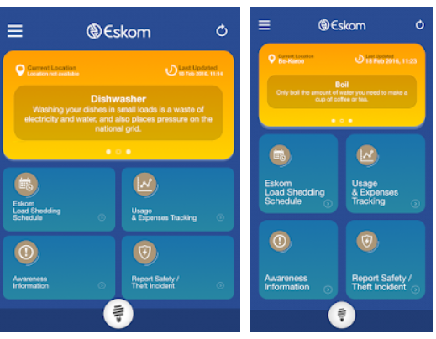fig 2 showing home page

## Nepal load-shedding android app

It is an application owned by the Nepal Electricity Authority (NEA) which is responsible for the generation and distribution of electric power in Nepal. The app was developed to serve a purpose of informing its customers about the current electricity status since Nepal is ravaged with electricity crisis. However, the system has its advantages and disadvantages according to the users.

## Advantages

* It is user friendly
* It offers real-time load-shedding schedules/its schedules are always accurate
* Offers offline support
* Consumer can post complain/feedback to NEA from a simple form
* Offers notifications whenever schedules change
* Customers can view latest news about NEA
* Integrated with google maps for locations
* Users can search schedules using location
* Schedules are in local Nepali language

## Disadvantages

* It is platform based since it is an android app so other mobile platforms are sidelined
* The app lacks updates making it to perform poorly
* Not convenient for foreigners since the schedules are in local language

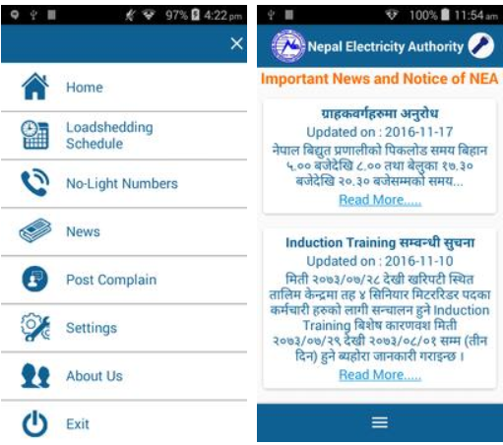fig 3 showing home page

# Key issues to take to design and implementation stage of the project

**User interface**

This will act a point of interaction between the user and the system. The interface will have to be user friendly.

**Database design**

This will involve creating a database that will meet the requirements of the system at hand.

**Test plan**

This will include a design of the test that will be used on the system to determine its robustness.

**Test case**

This will be a set of test conditions that the system tester will use to determine if the system has indeed met the requirements and is working properly.

**Deployment diagram**

This is a diagram that will shoe hoe the system is going to be deployed in the intended environment.

**Client server architecture**

This will show how the client computer are to interact with the server.

**User manual**

This will be a guide showing details on how the system should be installed to how it is supposed to be used.

# Conclusion

The literature review gives an understanding of the system that is being built based on the similar systems that were developed. It also gives a picture of the outcome from those similar systems. The various technologies are also reviewed to provide enlightenment to the system that is being developed.

# References

Anon., 2014-2019. *https://apkpure.com/.* [Online]   
Available at: https://apkpure.com/nepal-electricity-authority/com.nepal.peace.loadsheddingschedule  
[Accessed 30 january 2019].

Anon., 2016. *brookscanavesi.* [Online]   
Available at: http://brookscanavesi.com/uncategorized/benefits-disadvantages-hybrid-mobile-applications/  
[Accessed 25 january 2019].

Anon., 2017. *magetsi.me.* [Online]   
Available at: https://www.magetsi.me/  
[Accessed 29 january 2019].

Anon., 2019. *eskom.* [Online]   
Available at: http://www.eskom.co.za/CustomerCare/Pages/AppSelfService.aspx  
[Accessed 27 january 2019].